* THUMB = MOVEMENT Direction and strength ( replaces WASD and Shift)
  + For games that do not natively support analog input for movement, a modifier can be set up (i.e. auto holding [shift] when the stick mag is < 0.5 for a walk button)

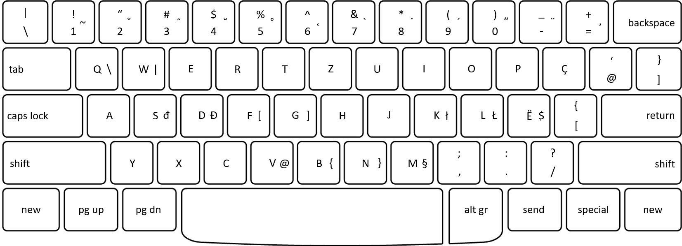

Primary Keys( Combat / Movement)

* ~~Walk Button~~
* Jump (ring)
* Crouch (pinky)
* Interact button (middle)
* Reload (index)

Secondary Keys( Requires fingers to relocate)

* 1,2,3,4,
  + Separate row of buttons, further up the controller

Tertiary Keys( Out of combat)

* Escape/Menu
* Drop Weapon
* Tab Menu

Radical design ideas:

* Larger scale device, includes all listed buttons (primary, secondary, tertiary)
* Smaller device, akin to a trackball mouse, includes primary and secondary buttons
  + Flat analog stick, held with thumb at an angle
  + Diagonal analog stick, fitted to thumb angle when holding the controller

| **Needs** | **Technical Requirements** |
| --- | --- |
| Controller might move around | Some way to affix the device to a desk/surface. Alternatively have a heavier weight. |
| Comfortable hand position | Ergonomics that funnel the hand into an intended, comfortable position. |
| Sizing | Fingers should be able to rest on all buttons at a time, regardless of hand size |
| Physical feedback for buttons | Make buttons with mechanical key switches |
| Enough buttons to play most games | Configurable keymaps, maybe additional macro keys? |
| Support for games that don’t natively support controller | Must be able to interpret analog inputs as Keyboard/Mouse inputs (analog->digital) |
| Buttons must not activate on accident | Buttons will have resistance |
| Directional movement must be precise an reflect the players intended input | Allow the player to calibrate the control stick so whatever feels like forward to them, is forward. |
| Plug and Play | Use controller button layout by default. ABXY L1,L2,R1,R2 . L-Stick  Some game-specific layout presets |